User Guide
UMGC CMSC 495 Section 6384
Arora, Neil
Pierce, Holden
Stigall, Michael
Thompson, Kosie

Table of Contents
1 Overview of the Software
2 Purpose of the User Guide
3 Target Audience
4 Getting Started
5 Installation Instructions
6 System Requirements
7 User Interface Overview
8 Using the Software
9 Step-By-Step Instructions of Using the Software’s Main Features
10 Troubleshooting Tips
11 Reference
12 Glossary of Terms
13 Index

Introduction
This user guide provides instructions and information for installing, launching and playing the Breakout-style game developed as part of this project. The purpose of this guide is to help users understand the software’s functionality, controls, and features.
The guide is intended for end users who wish to run and interact with the game on a supported desktop platform. For information on installation, please see section five, and for information on system requirements, please see section six. No prior programming experience is required. Basic familiarity with keyboard input and desktop applications is sufficient to operate the software. Additionally, this guide will provide guidance on navigating the various menus, starting with playing the game.

1 Overview of the Software
The software is a modern implementation of the classic Breakout arcade game, developed using the Python programming language and the Pygame framework. The game runs as a desktop application and provides an interactive, real-time gameplay experience. The player controls a paddle to bounce a ball and destroy blocks arranged on the screen, advancing through multiple levels.
The primary objective of the game is to destroy all blocks in each level, while preventing the ball from falling below the paddle. The player earns points for each block destroyed and begins the game with a limited number of lives. Each time the ball falls below the paddle, the player loses one life. When all lives are lost, the game transitions to the Game Over state and provides the option to restart or exit.
The software includes several key components, including a main menu, gameplay screen, scoring system, life counter, and Game Over screen. The main menu allows the player to start a new game. During gameplay, the user interface displays the current score and remaining lives. The Game Over screen provides feedback when the player has exhausted all lives and allows the player to restart or exit.
The software is designed to be responsive, easy to understand, and visually clear. Core gameplay mechanics operate in real time, and user input is processed immediately to ensure smooth and predictable control. The system is intended to be accessible to users of varying experience levels while maintaining the challenge and engagement associated with classic arcade gameplay.

2 Purpose of the User Guide
The purpose of this User Guide is to provide clear, step-by-step instructions for installing, configuring, launching, and interacting with the Breakout Game application developed in CMSC 495. This guide serves as the primary reference for end users who wish to run the application on a supported desktop system without requiring access to the source code or prior development knowledge.
This document explains the software’s purpose and gameplay objectives, system and environment requirements, installation and dependency setup, how to launch and operate the application, how to execute unit tests, and troubleshooting common issues.
The guide ensures users can successfully install and run the software in a clean environment using the correct Python and Pygame versions. It reflects the finalized Phase 2 implementation, including validated gameplay mechanics, modular architecture (Core, Objects, Assets), and verified unit testing using pytest.

3 Target Audience

3.1 End Users (Primary Audience)
Individuals who wish to install and play the Breakout Game on a desktop computer. These users have basic familiarity with installing software, using the command line, and operating keyboard controls. No programming knowledge is required.

3.2 Technical Reviewers and Instructors
Course instructors, evaluators, and reviewers who need to verify system functionality, install and run the application, execute unit tests, and confirm compatibility with stated system requirements.

3.3 Developers and Maintainers
Future developers who may clone the repository and expand functionality. This guide provides environment setup instructions, dependency management details, and validated test execution steps used during Phase 2.

4 Getting Started
Step 1: Obtain the Project Files
Download or clone the project repository from:
https://github.com/nerf187/UMGC-Breakout-Game
If using Git:
git clone https://github.com/nerf187/UMGC-Breakout-Game.git
Ensure the project folder contains: breakout.py, Core/, Objects/, Assets/, and tests/. Run the game from the project root directory.
Step 2: Install Python
Download Python from https://www.python.org/downloads/
Recommended version: Python 3.11 or 3.12
Verify installation using:
python --version
Step 3: Install Required Dependencies
Install Pygame:
python -m pip install pygame
If installation fails (Python 3.14+), install pygame-ce:
python -m pip install pygame-ce
Step 4: Navigate to the Project Directory
Open a terminal and change into the project root directory:
cd path/to/UMGC-Breakout-Game

5 Installation Instructions

5.1 Install Python
1. Download Python 3.11 or 3.12.
2. Select 'Add Python to PATH' during installation.
3. Verify installation using: python --version

5.2 Install Required Package (Pygame)
Install using:
python -m pip install pygame
If necessary:
python -m pip install pygame-ce

5.3 Launch the Application
From the project root directory, run:
python breakout.py
The Main Menu screen should appear.

5.4 Running Unit Tests (Phase 2 Validation)
To execute the test suite:
python -m pytest -q tests
All tests should run without unexpected failures.

5.5 Installation Verification Checklist
Installation is successful if:
- Python version is compatible
- Pygame installs without errors
- breakout.py launches successfully
- Main Menu screen appears
- Controls respond correctly
- pytest executes and detects tests

6 System Requirements
System Requirements (Breakout Game)
The Breakout game is a local Python/Pygame application designed for Windows and macOS systems.
Python and a compatible Pygame package must be installed before running the game.
Minimum Requirements
• Operating System: Windows 10+ or macOS 11+
• Python: 3.10–3.13(3.14 can work but needs a different pygame installation)
• Graphics/Display: Any standard display
• Input: Keyboard
• Storage: ~200 MB free space (project + dependencies)

Recommended Requirements
• Operating System: Windows 11 or latest macOS
• Python: 3.11 or 3.12
• Display: 1280×720 or higher

Compatibility Note (Important)
• Python 3.14+ is not yet supported by pygame. If installation fails, install pygame-ce instead:
python -m pip install pygame-ce

7 User Interface Overview
The Breakout game uses a simple set of screens that guide the player from starting the game to selecting a level, playing, and viewing results.
Start Screen (Main Menu)
When breakout.py is launched, the Start Screen displays the title BREAKOUT with two options:
- Press SPACE to Start
- Press ESC to Quit
Level Select Screen
After starting, the SELECT LEVEL screen appears:
- The selected level is highlighted (green with >>)
- UP/DOWN arrows change the selection
- ENTER confirms the level and loads gameplay
Gameplay Screen (Level Loaded)
Once a level loads, the screen shows the play area and HUD:
- Top-left: Score and Lives (example: Score: 0 Lives: 3)
- Top-right: Current Level number (example: Level: 1)
- Center: Block layout (varies by level)
- Bottom: Paddle and ball starting position
- A prompt appears: Press SPACE to Launch (launches the ball to begin the round)
Level Complete Screen
When all blocks in a level are cleared, a LEVEL COMPLETE! screen appears showing the score and options:
- SPACE: Next level
- R: Replay level
- ESC: Quit
Game Over Screen
When the player loses all lives, the GAME OVER screen appears showing the final score and options:
- R: Restart
- ESC: Quit

8 Using the Software
Task 1: Launching the Game
- Navigate the project folder on your computer.
- Double-click breakout.py to open (or right-click and select Run with Python).
- Press SPACE on the Title Screen to proceed.
- Use the UP/DOWN ARROW keys to highlight a level and press ENTER to load it.
  - Outcome: The game environment initializes, and the paddle/ball appears in the "Ready" state.
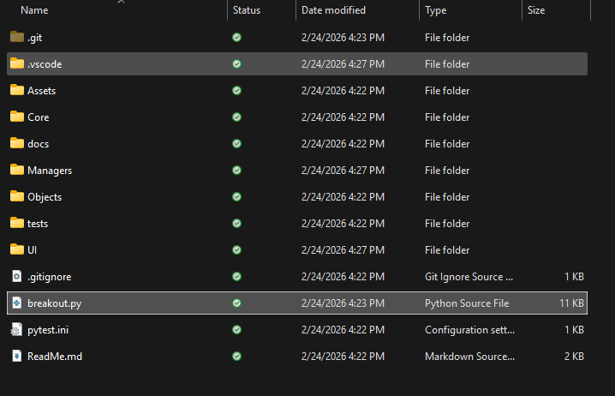
Figure 1: Opening breakout.py from project folder.

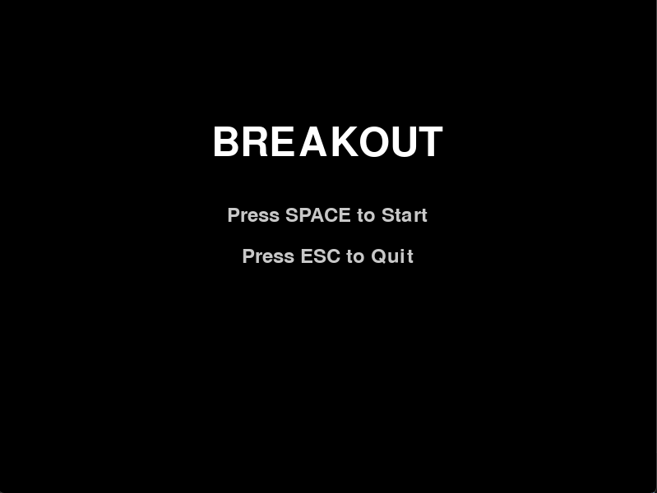
Figure 1A: Breakout main menu screen after running breakout.py.

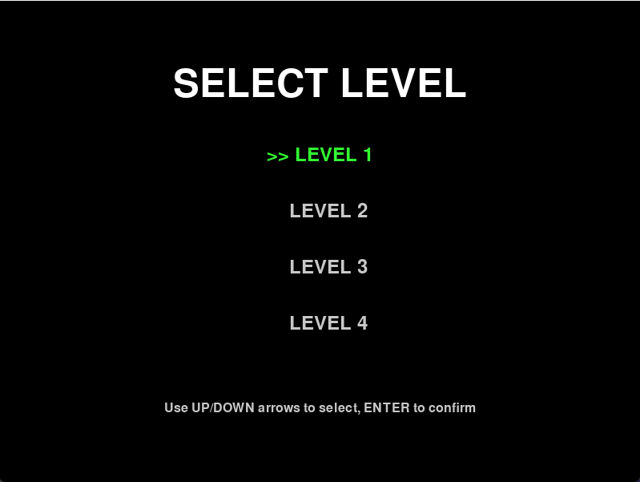
Figure 1B: Select Level Screen (Use shown inputs to select level).

Task 2: Launching and Controlling the Ball
- Release: When the "Press SPACE to Launch" prompt appears, press SPACE.
- Move: Use the A / LEFT ARROW or D / RIGHT ARROW keys to slide the paddle.
- Goal: Deflect the ball into the blocks. The round continues until all blocks are destroyed or the ball falls off the bottom of the screen.
  - Tip: If the paddle doesn't move, click the game window to ensure it is the active window.
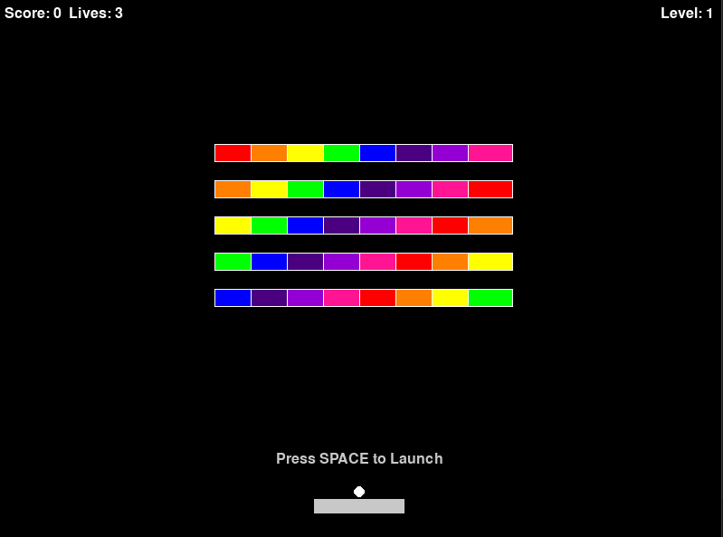
Figure 2: Screen after selecting level.
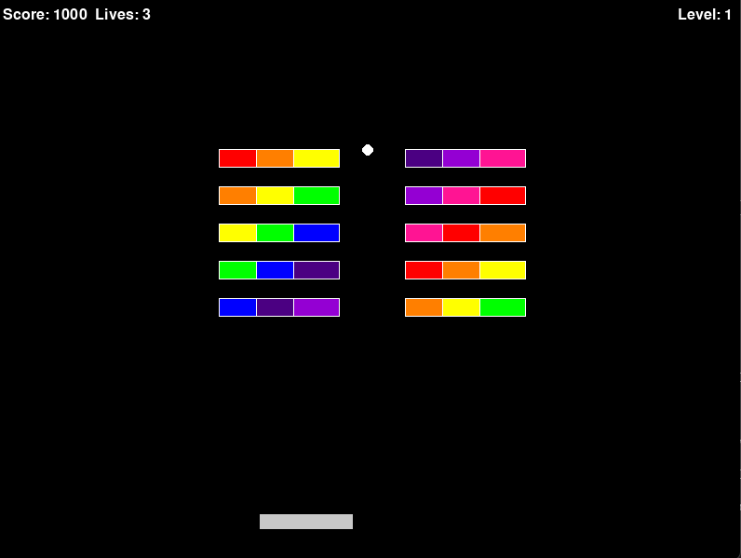
Figure 2A: Ball in action after starting game.

Task 3: Level Completion
- Win Condition: Destroy all blocks on the screen to trigger the Level Complete screen.
- Next Steps:
  - Press SPACE to advance to the next level.
  - Press R to replay the level you just finished.
  - Press ESC to exit software.
  - Outcome: The game loads the new layout or resets the current one with a fresh score for that stage.
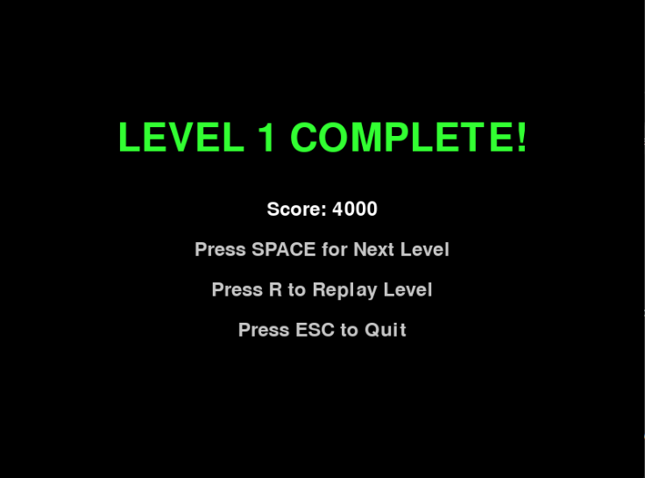
Figure 3: Level completion screen when level is completed.

Task 4: Handling Lives and Game Over
- Losing a Life: If the ball passes the paddle, you lose one life. The ball returns to the paddle. Press SPACE to launch again.
- Game Over: If you lose all lives, the Game Over screen displays your final score.
- Restart/Exit:
  - Press R to restart the current level immediately.
  - Press ESC to exit the software.
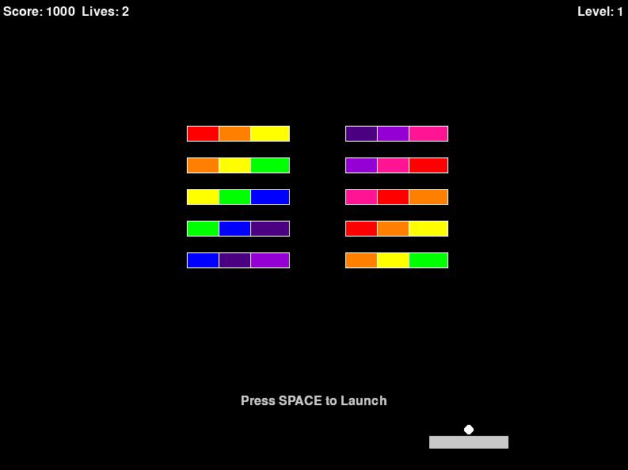
Figure 4: You should see that the lives counter goes down when missing the ball.
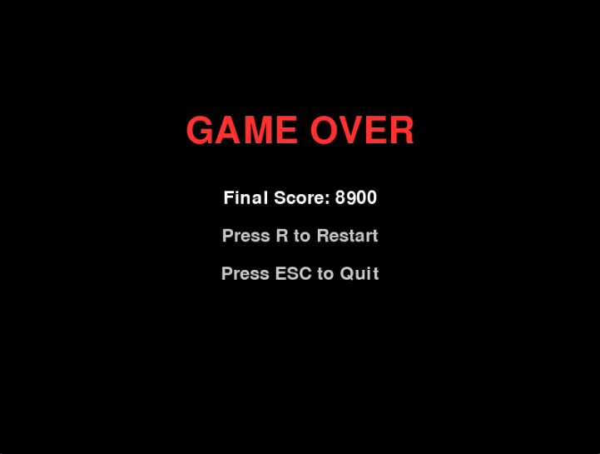
Figure 4A: Game over screen displays when all lives are lost.

9 Step-By-Step Instructions For USing The Software’s Main Features
Game Start:
From the Main Menu, press SPACE to start.
The game will load Level Select. Use the arrow keys to navigate to the desired level and press ENTER to confirm.
Gameplay:
Press SPACE to launch the ball.
Use the Left Arrow (←) key or (A) to move the paddle left.
Use the Right Arrow (→) key or (D) to move the paddle right.
Scoring and Lives:
Level complete when all bricks have been destroyed.
After completing a level, press SPACE for Next Level, (R) to Replay, or (ESC) to Quit.
The player begins the game with 3 lives. One life is lost each time the ball falls past the bottom edge of the screen.
Each brick broken awards points. Total points are shown in the top left and at end of game.
When you complete the last level, the game will end and show “You Win!”

10 Troubleshooting Tips
Use this section to solve the most common setup and runtime issues.
Game won’t start / closes immediately
- Make sure you are running the correct file:
python breakout.py
- Run the command from the project root folder (the folder that contains breakout.py, Objects/, Core/, and Assets/).
“ModuleNotFoundError: No module named ‘pygame’”
- Pygame is not installed in your current Python environment.
- Install it with:
python -m pip install pygame
Pygame install fails (especially on newer Python versions)
- If you are using a very new Python version (example: Python 3.14+), normal pygame may fail to install.
- Install pygame-ce instead:
python -m pip install pygame-ce
“No such file or directory” for levels/assets (missing JSON/images)
- You are likely running the game from the wrong folder.
- Fix: cd into the project root and run again:
python breakout.py
Controls not working
- Click inside the game window once to ensure it has focus.
- Use the controls shown in-game (examples from our UI):
  - SPACE to start/launch/continue
  - ESC to quit
  - UP/DOWN + ENTER to select a level
  - R to replay/restart on win/game over screens
Tests say “0 tests ran”
- You probably ran the wrong tool (like unittest) or ran from the wrong folder.
- Run pytest from the project root:
python -m pytest -q tests
Tests open a Pygame window
- You may be running pytest without limiting it to the tests/ folder.
- Run:
python -m pytest -q tests

11 Reference
For authoritative information on the underlying technologies, consult the following official resources:
- Python Official Documentation:
https://docs.python.org/3/
- Pygame Documentation:
https://www.pygame.org/docs/
- Pygame Community Edition (CE):
https://github.com/pygame-community/pygame-ce
For bugs specific to Block Breaker Mania, or if the resources above do not resolve the issue, please reinstall the application:
https://github.com/nerf187/UMGC-Breakout-Game

12 Glossary Of Terms
Ball: The active projectile that collides with bricks and the paddle. The ball launches from the paddle at the start of each life and must be kept in play to destroy bricks.
Brick: A destroyable object arranged in rows at the top of the screen. The player advances to the next level when all bricks are cleared from the screen. Each brick destroyed adds to the player's score.
Paddle: The player-controlled horizontal bar at the bottom of the screen used to deflect the ball and prevent it from falling. Controlled using the Left Arrow (←) or A key and Right Arrow (→) or D key.
Life: A unit representing the number of attempts remaining. The player starts with three lives. One life is lost each time the ball falls past the bottom edge of the screen.
Score: A numerical value representing the player's progress, increased by destroying bricks. The current score is displayed in the top left corner of the screen during gameplay and is shown again at the end of the game.
Level Select: A screen displayed after starting a new game that allows the player to choose which level to play using the arrow keys and Enter key.
Main Menu: The initial screen displayed when the game is launched. From here, the player can start a new game by pressing the Spacebar.
Game Over: The state reached when the player's life count reaches zero. At this point, no further gameplay is possible, and the player must restart from the beginning.
Pygame: A set of Python modules designed for writing video games. It provides computer graphics and sound libraries used to build this software.
Python: The programming language used to develop the Block Breaker Mania game.

13 Index
- A
  - Arrow Keys (controls), 9
- B
  - Ball, 1, 7, 9, 12
  - Bricks, 1, 7, 9, 12
- C
  - Controls (keyboard), 9
- D
  - Documentation (Python/Pygame), 11
- E
  - Exit (game), 1, 9
- G
  - Game Over, 1, 9, 12
  - Getting Started, 4
- I
  - Installation, 5, 11
  - Interface (user), 7
- K
  - Keyboard controls, 9
- L
  - Launching the game, 4
  - Level Select, 9, 12
  - Levels, 1, 9
  - Lives, 1, 7, 9, 12
- M
  - Main Menu, 1, 7, 9, 12
- N
  - Next Level, 9
- O
  - Objective (game), 1
  - Overview (software), 1
- P
  - Paddle, 1, 7, 9, 12
  - Points (scoring), 1, 9
  - Pygame, 1, 11, 12
  - Python, 1, 11, 12
- R
  - Reinstall application, 11
  - Replay level, 9
  - Requirements (system), 6
  - Restart game, 1, 9
- S
  - Score, 1, 7, 9, 12
  - Spacebar (controls), 9
  - System requirements, 6
- T
  - Target audience, 3
  - Troubleshooting, 10, 11
- U
  - User guide purpose, 2
  - User interface, 7
- W
  - "You Win!" screen, 9

